- Purpose
  - The purpose of this document is to describe the procedure for prepping and checking a Stealth DRS Rider machine before shipment.
- Scope
  - This SOP applies to all equipment assembly team members. The process applies to the following machine ID’s:
E029926PKG0600BE1200 – Stealth DRS26BT w/4-6V 235AH Wet Bat, 25 Amp Charger
E029927PKG0600BE1200 – Stealth DRS26BT w/4-6V 200AH AGM Bat, 25 Amp Charger
E029931PKG0600BE1200 – Stealth DRS32BT w/4-6V 235AH Wet Bat, 25 Amp Charger
E029932PKG0600BE1200 – Stealth DRS32BT w/4-6V 200AH AGM Bat, 25 Amp Charger
- Responsibilities
  - The operations manager/supervisor is responsible for enforcing this SOP.
- Materials
  - The proper materials needed for this process are listed on the machine work order.
- Definitions

- Procedure
  - Begin by taking a base machine (29925 or 29930) out of the box. Set all of the components aside that come with it.

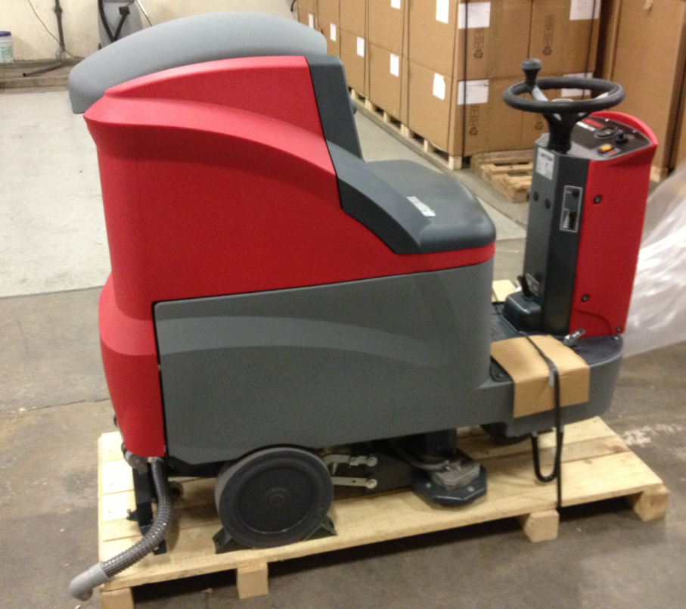

  - Open up the battery compartment and remove the components that are inside.
  - Put the key into the keyswitch, but don’t turn the machine on yet.

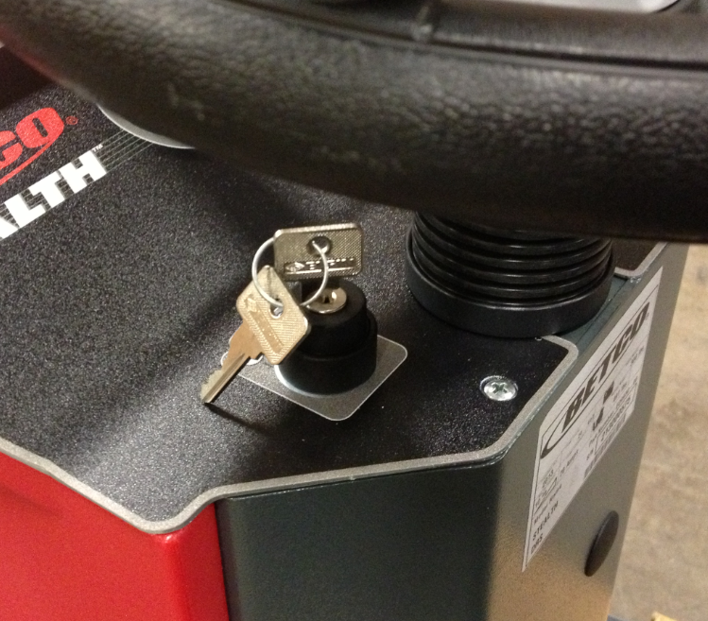
  - lace 4 batteries (86277 for wet cells or 88031 for AGM) into the battery compartment in the orientation shown. The negative terminals should face the outside of the machine.

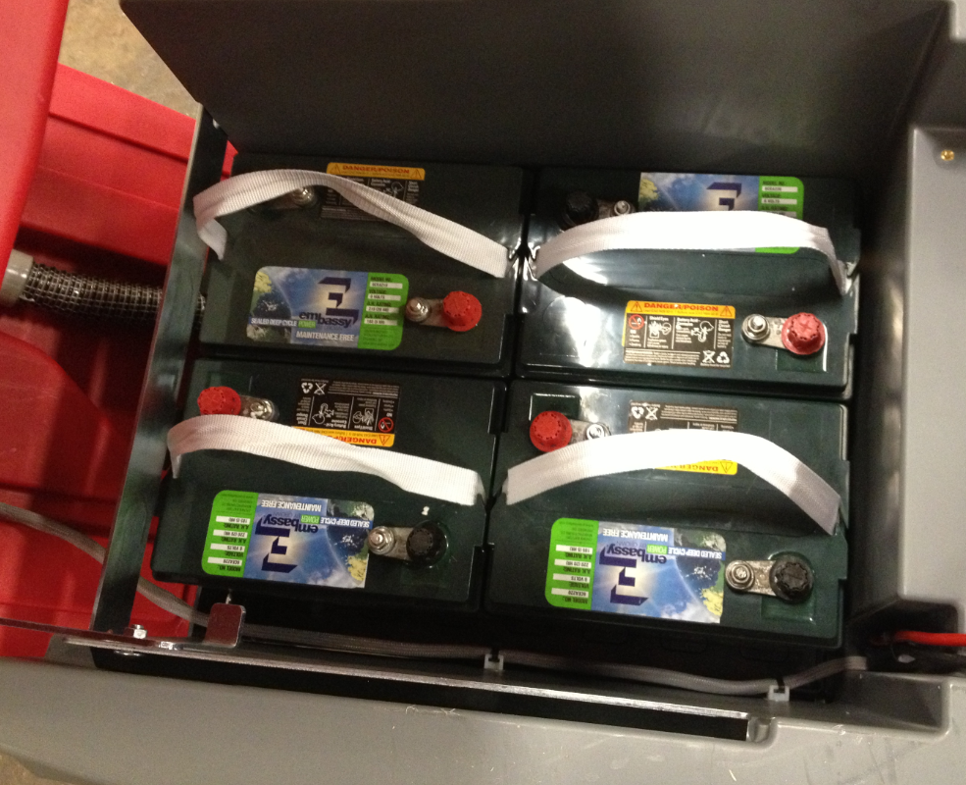

  - Wire up the batteries as shown in the photo.

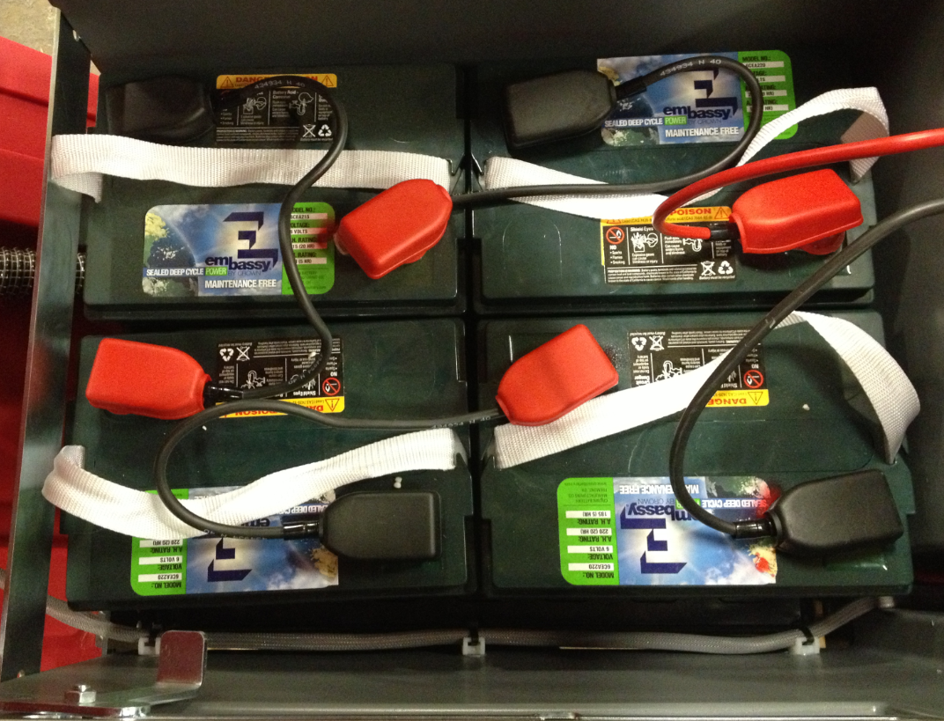
  - If AGM batteries are being used, place a “Maintenance Free” (88897) decal onto each battery.

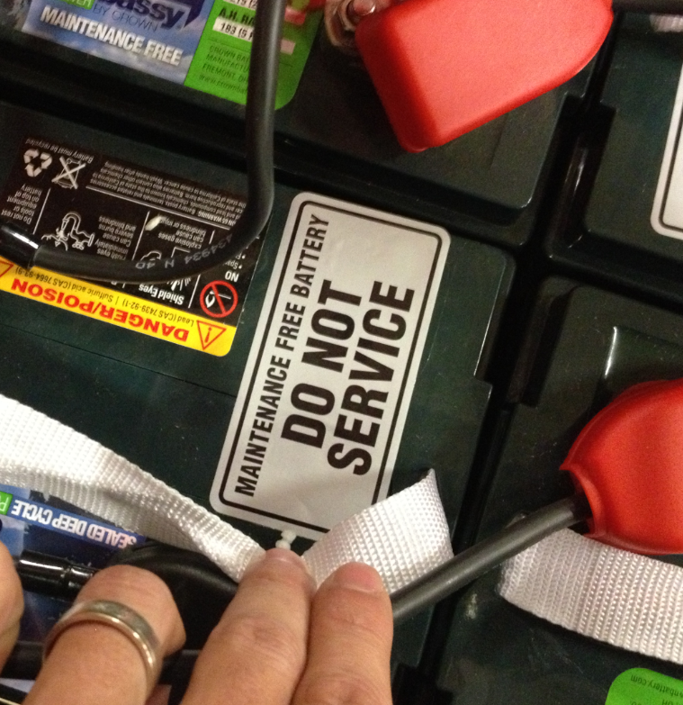

  - Connect the pigtail from the batteries to the machine.

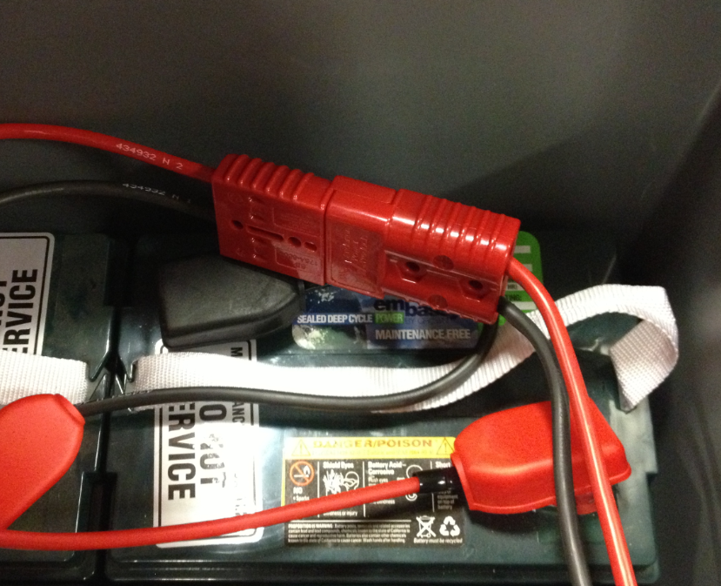

  - Close the battery compartment.

  - Install the filter in the location shown. It is under the front of the machine. Place the screen into the cap and then thread the cap into place.

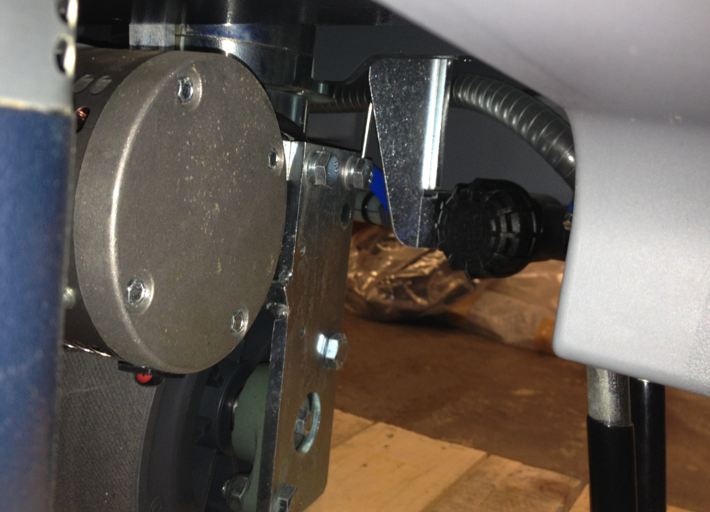

  - Place a left and right side machine decal (89571 and 89572 for 26” machines or 89573 and 89574 for 32” machines) onto the appropriate sides of the machine as shown. Position the rear edge of the decal along the seam in the tank and locate the rounded edge about 1” down from the rounded styling on the tank.

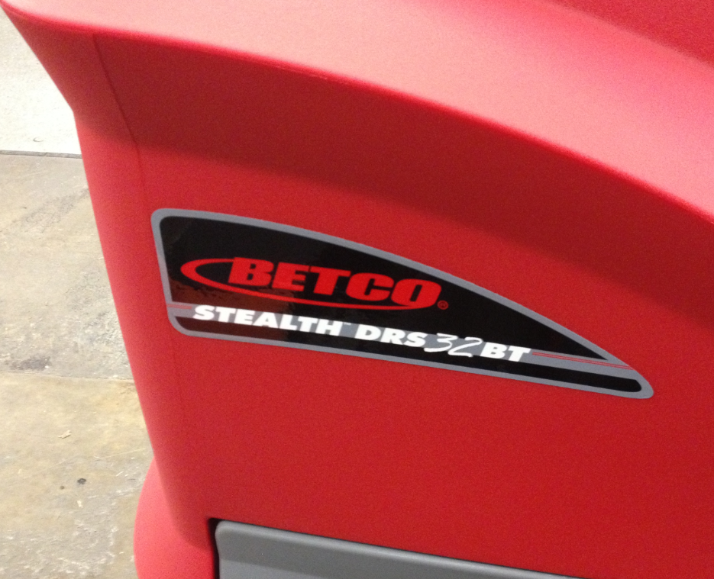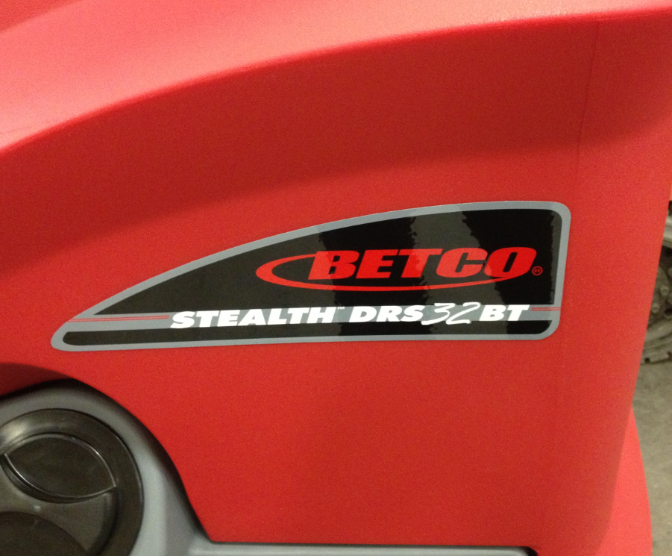
1” from countour
Line up with seam in tank

  - If the machine has AGM batteries, the BDI setting needs to be changed. To do this remove the 2 screws from the top edge of the instrument panel. If the machine has wet cell batteries, proceed to step 5.18.

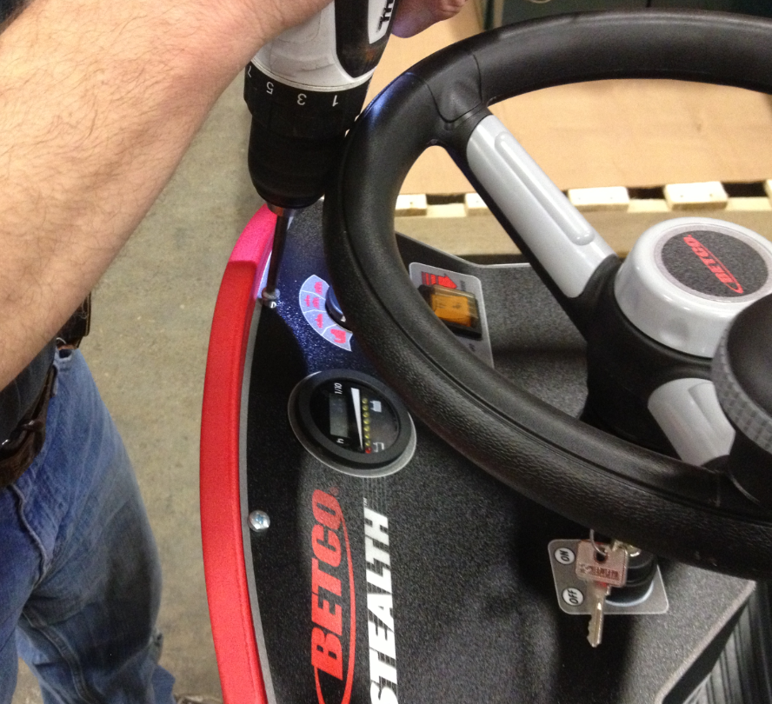

  - Also remove the 2 screws shown on each side of the steering column.

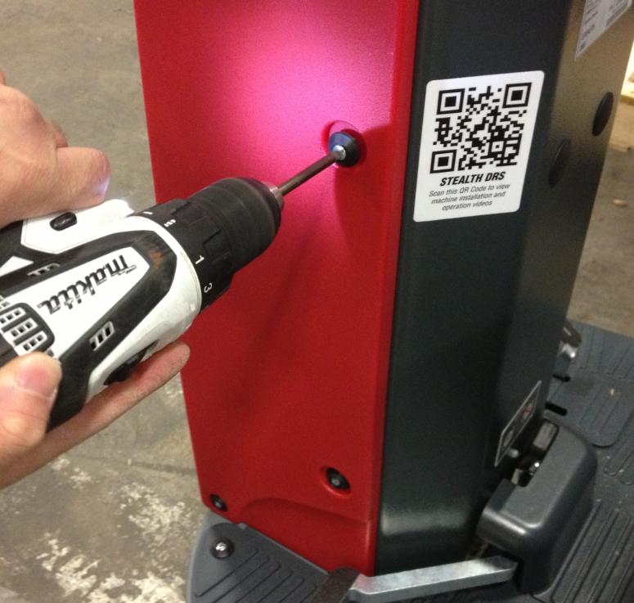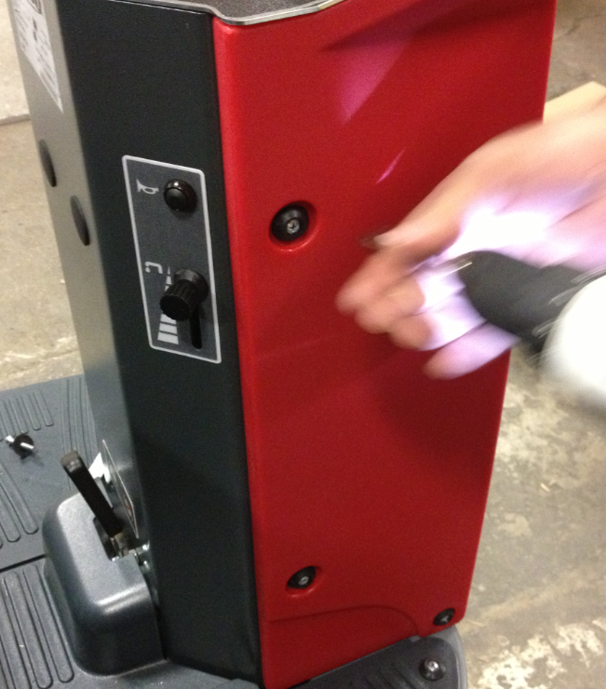

  - Remove the cover to expose the controls.

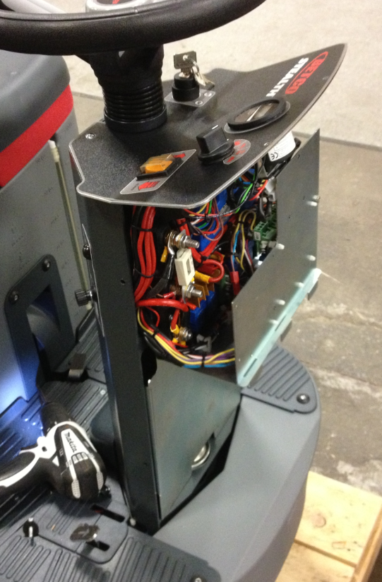

  - Turn the dial on the back of the BDI to position “4”.

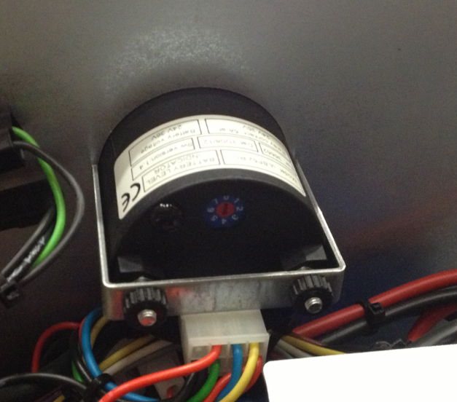

  - Turn the machine on and watch the lights on the front of the BDI when doing this. With AGM batteries, the 4th light on the BDI should briefly light up.
  - Re-assemble the steering column. Verify that the parking brake is set on the machine.
  - Remove all of the plastic wheel chocks from the pallet. With the power to the machine “on”, turn the function knob to raise the deck and the squeegee.

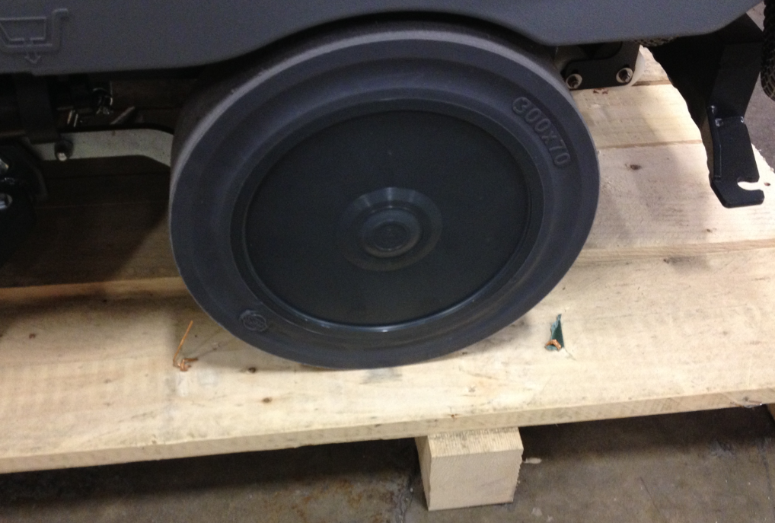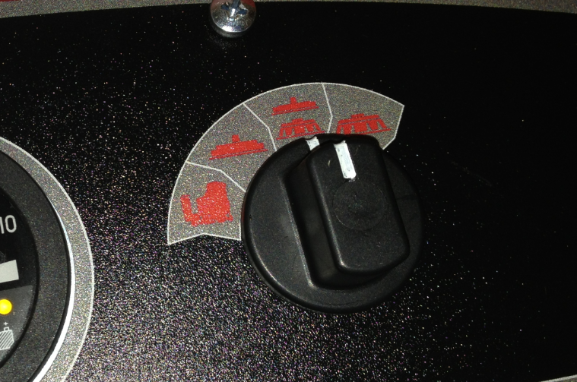
  - Tuck the vacuum hose under the machine so that it does not get run over when driving the machine off of the pallet.

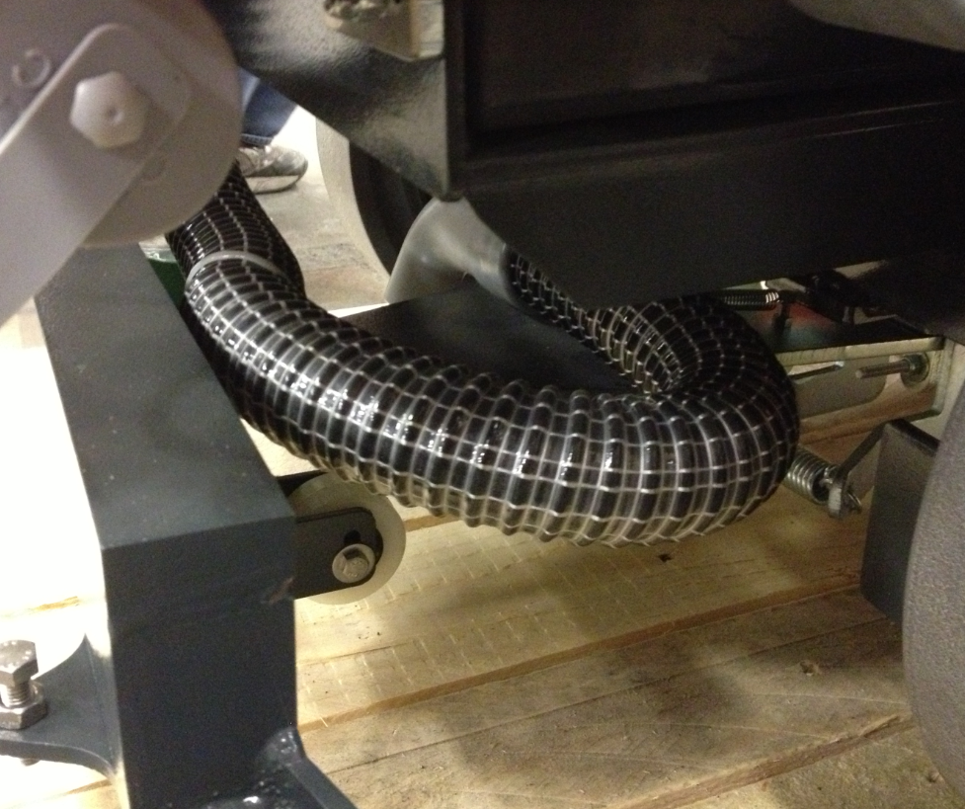

  - Place the ramp behind the machine, release the parking brake, and drive the scrubber off of the pallet.

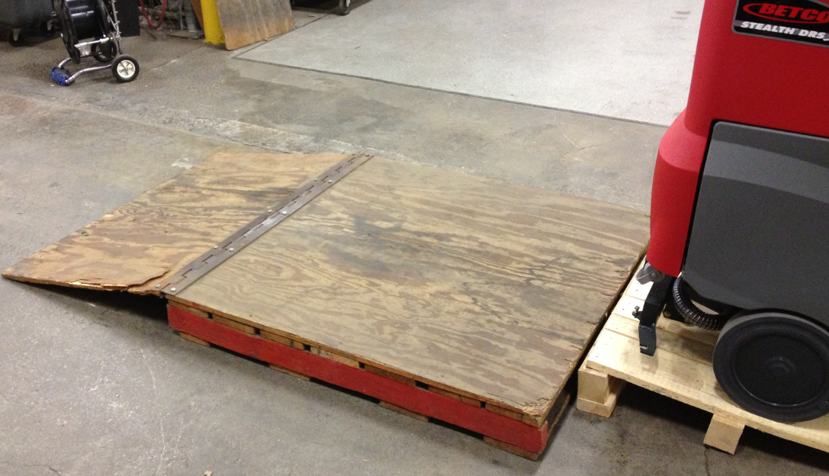

  - Take the machine to the testing area and put 4 gallons of washer fluid into the solution tank.
  - Set the parking brake and put the toggle switch shown into the “forward” position.

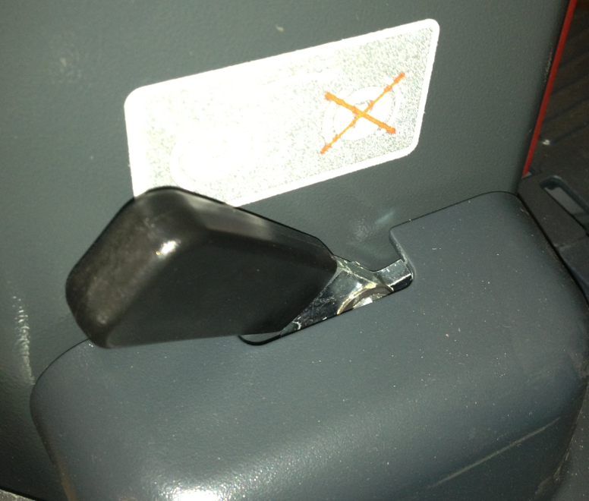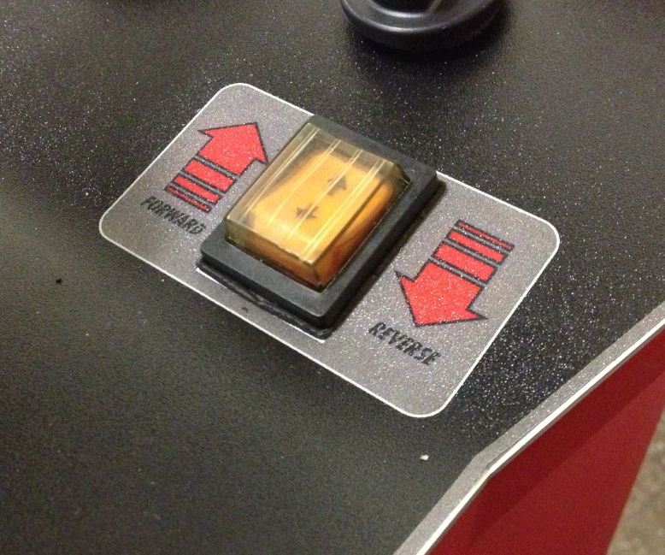
  - Turn the dial shown on the control panel to the position that shows the brush and the squeegee.

  - Use your hand to press down the accelerator pedal. The scrub deck and the squeegee should lower. The vacuum motor should also turn on. Place your hand over the open end of the vacuum hose to make sure you have proper suction. When the pedal is released, they should go back up. Repeat this a couple times to make sure that everything works properly.

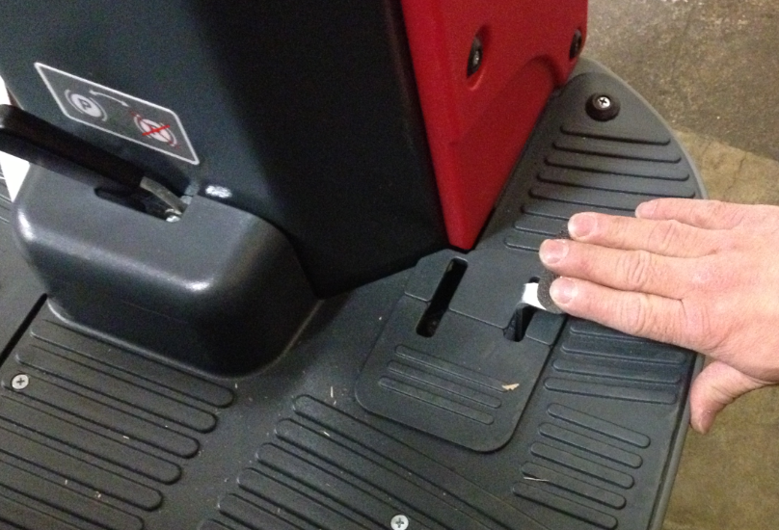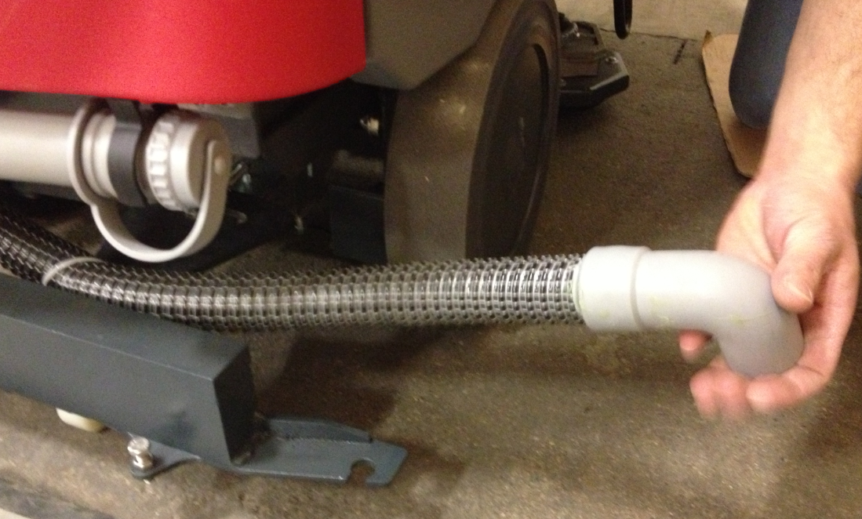

  - Press the accelerator pedal down again until solution flows from each side of the scrub deck. If solution does not flow, check to see that the solution lever is open all the way. If it is, keep checking the solution system until the problem is solved.

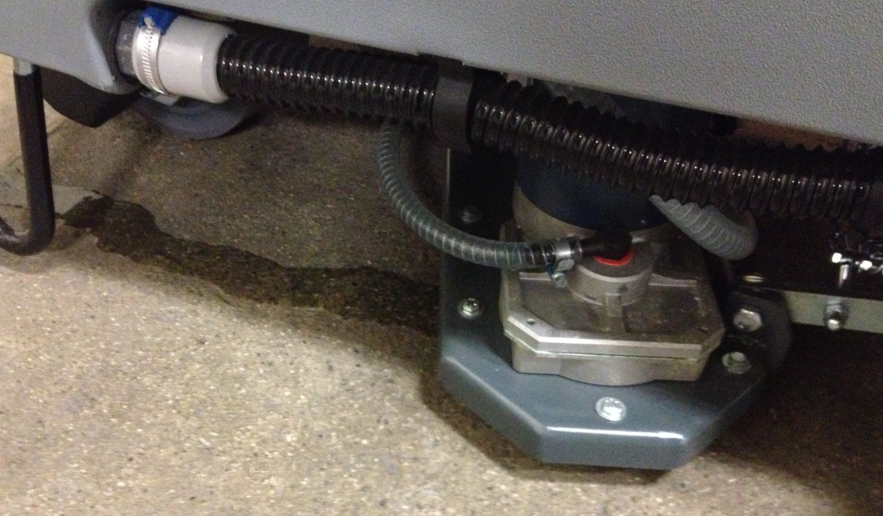
  - Release the pedal once proper flow is achieved.
  - Remove the plug from the end of the solution tank drain hose and drain the tank.

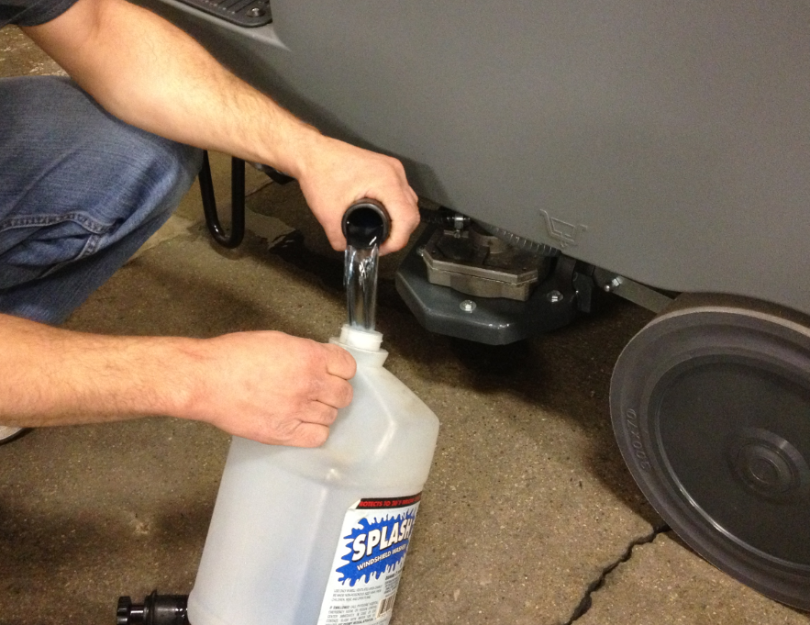

  - Release the parking brake and drive the scrubber up the ramp and back onto the pallet. Try to position it so that the wheels sit on the runners. Set the parking brake so that the machine does not roll.

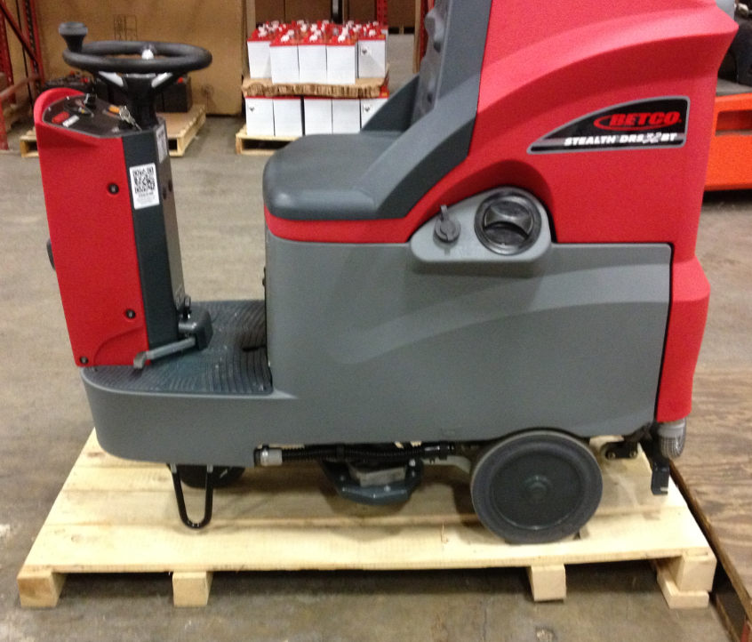

  - Turn the dial on the control panel back to the brush and squeegee position. Press the accelerator pedal with your hand until the scrub deck and the squeegee yolk are in the down position. Without taking your hand off of the pedal, use your other hand to turn the machine key to the “off” position. This will keep the deck and the squeegee in the lowered position for shipment.

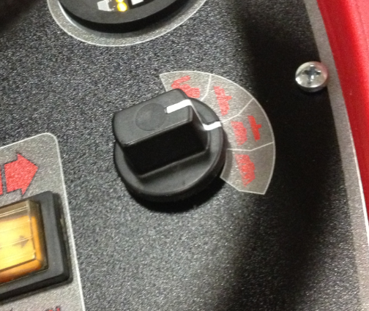

  - Open up the battery compartment and unplug the battery connector.

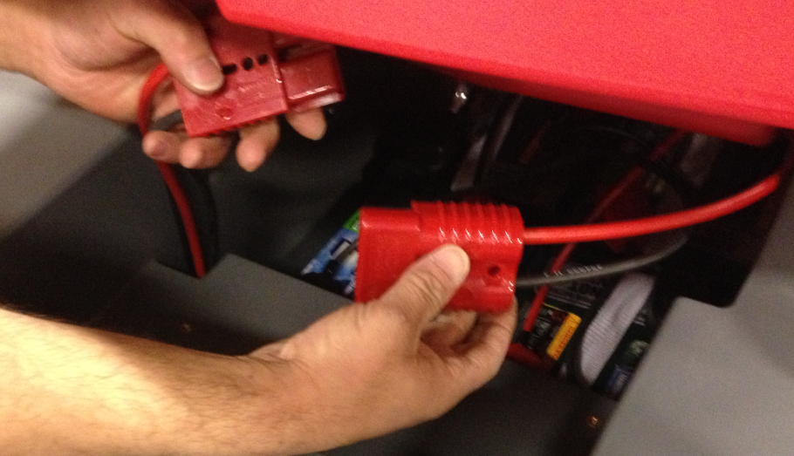

  - Screw 2x4’s in front of and in back of each of the rear wheels. Also put a 2x4 on the front side of the front wheel.

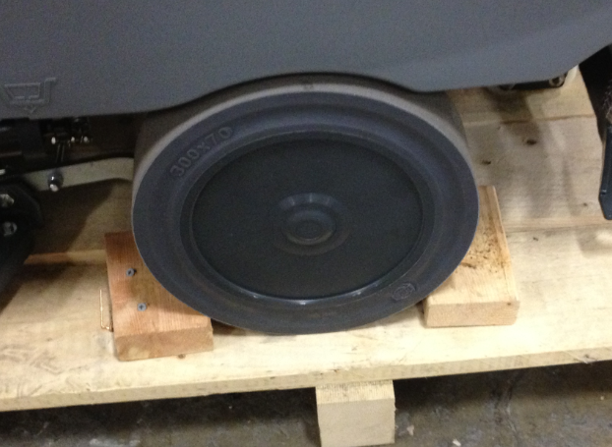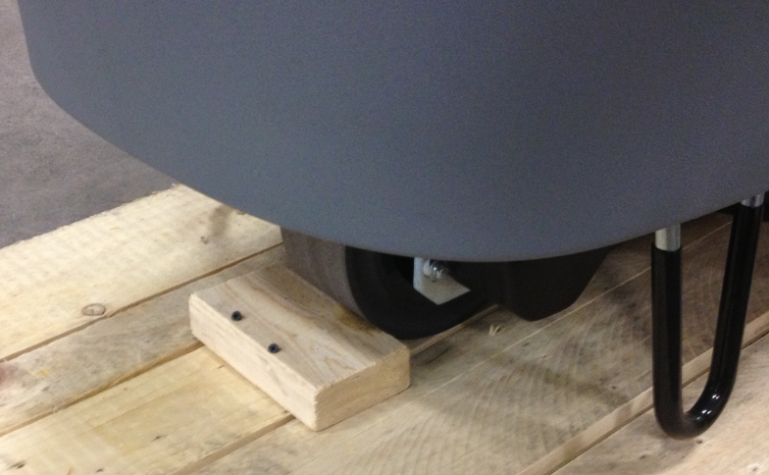
  - Place a band over the front of the machine in the location shown. Use the cardboard that came with the machine to protect the corners.

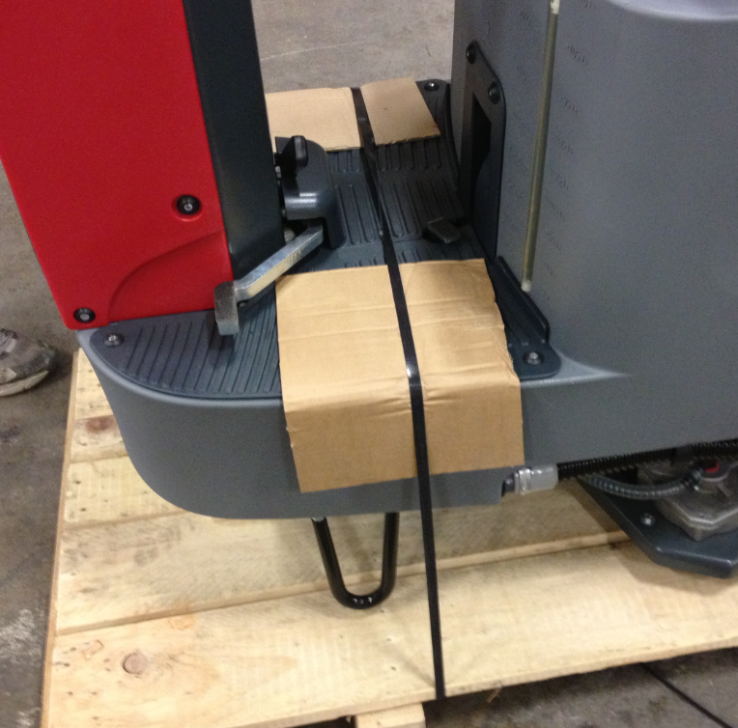

  - Place a ramp alongside of the machine as shown. Put some plastic behind it so that it does not scratch the machine. Also, attach the label on the ramp that is shown. You may need to lean something against the ramp to hold it in place until it is banded.
  - Place a band over the battery compartment as shown. This will also hold the ramp in place.

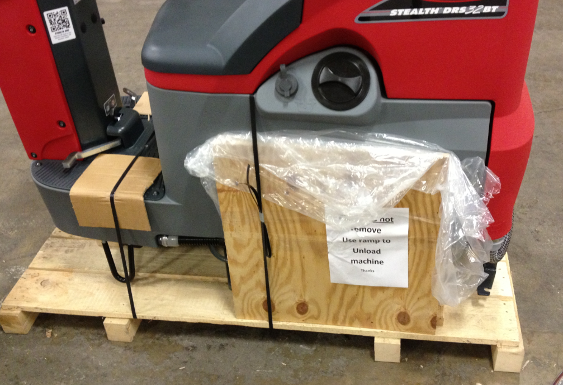

  - Close the battery compartment.

  - Place the pad drivers onto the machine in the location shown.

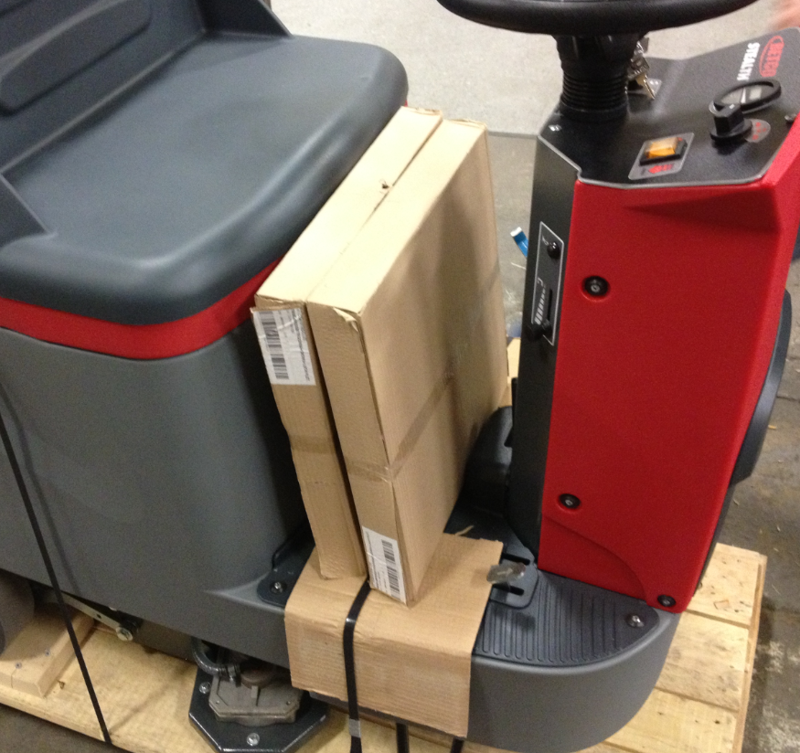

  - Place the brush skirts next to the pad drivers.

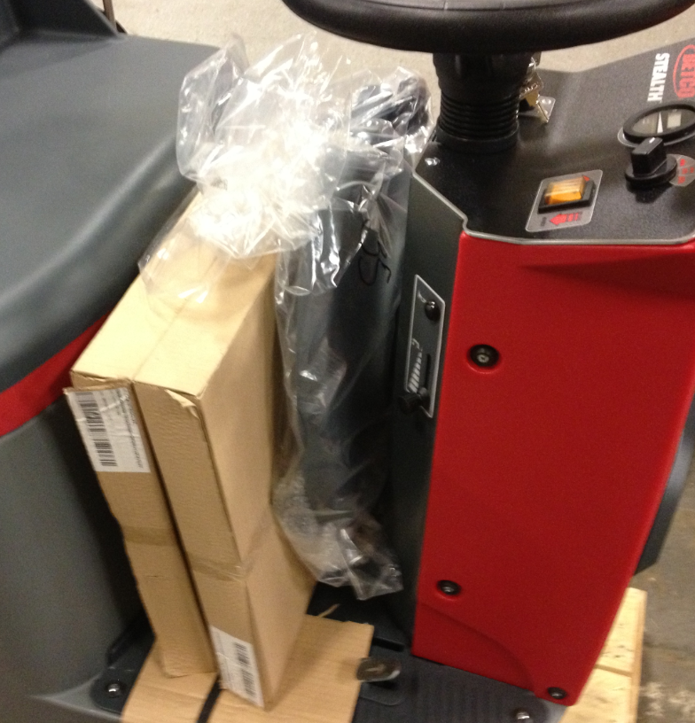

  - Place a yellow QC tag onto the machine in the location shown.

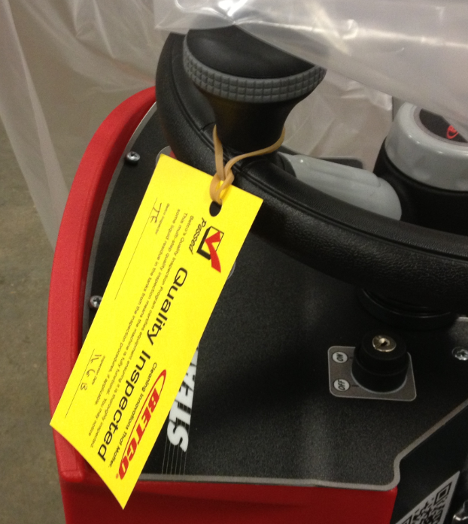
  - Put a manual packet together that includes a manual and a warranty card. Remove the key from the machine and place it into the bag.
  - Place the plastic bag that came with the machine back over it.

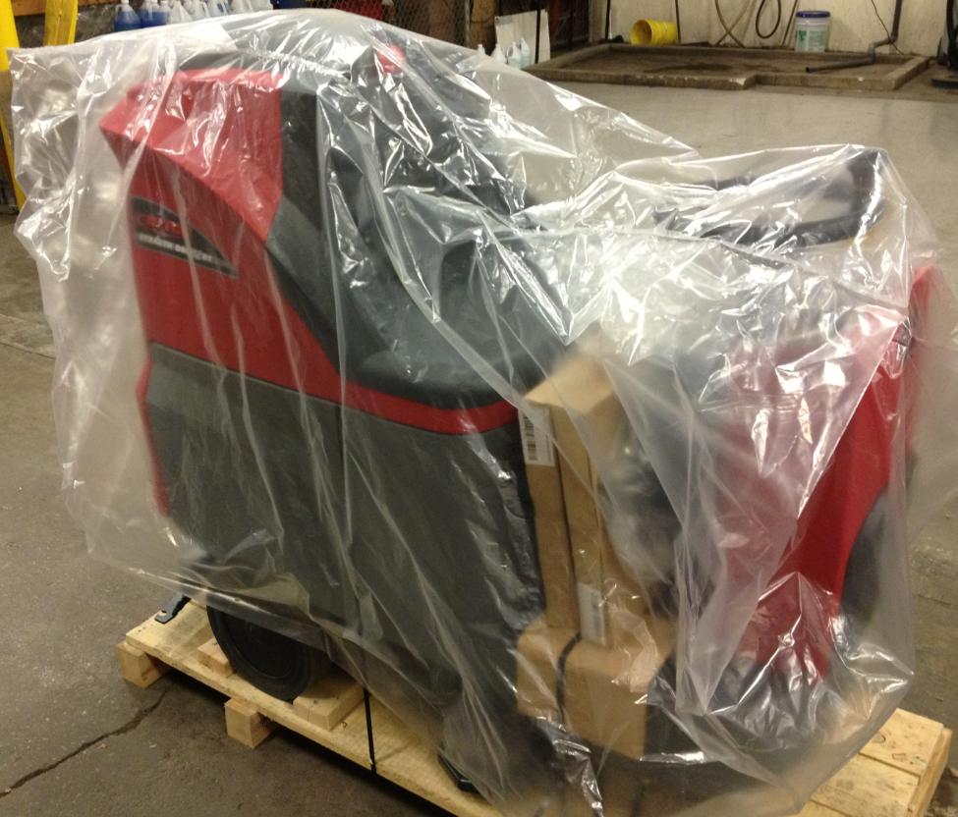

  - Place the appropriate charger (88036 for wet cells or 88458 for AGM) onto the seat.

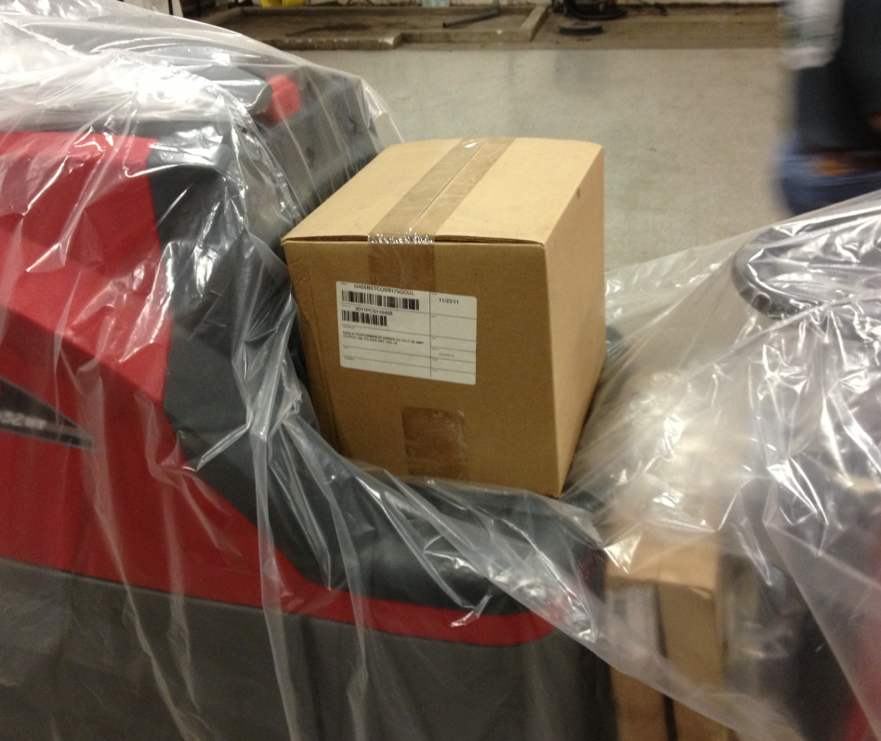

  - Place the manual packet onto the charger and tape it into place.

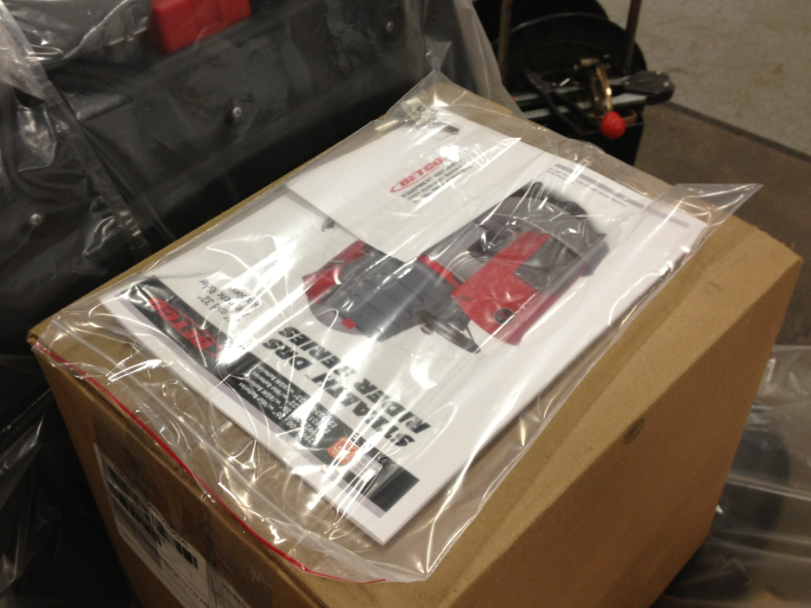
  - Place the squeegee onto the machine in the location shown. Wrap tape around everything to hold it in place.

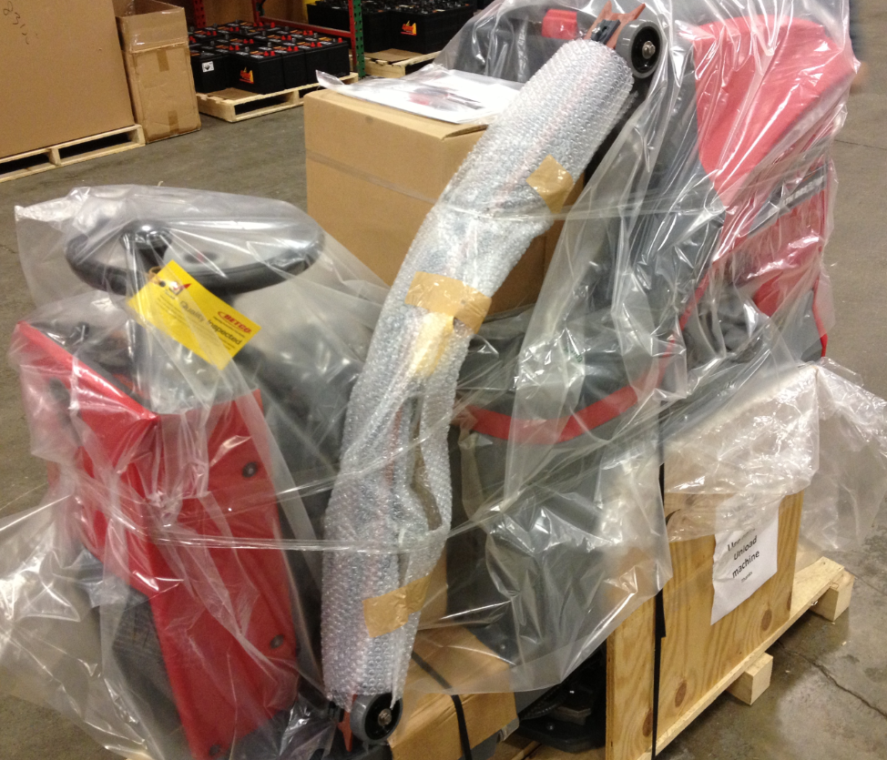

  - Place the shipping box back over the machine and use two bands to hold it in place.

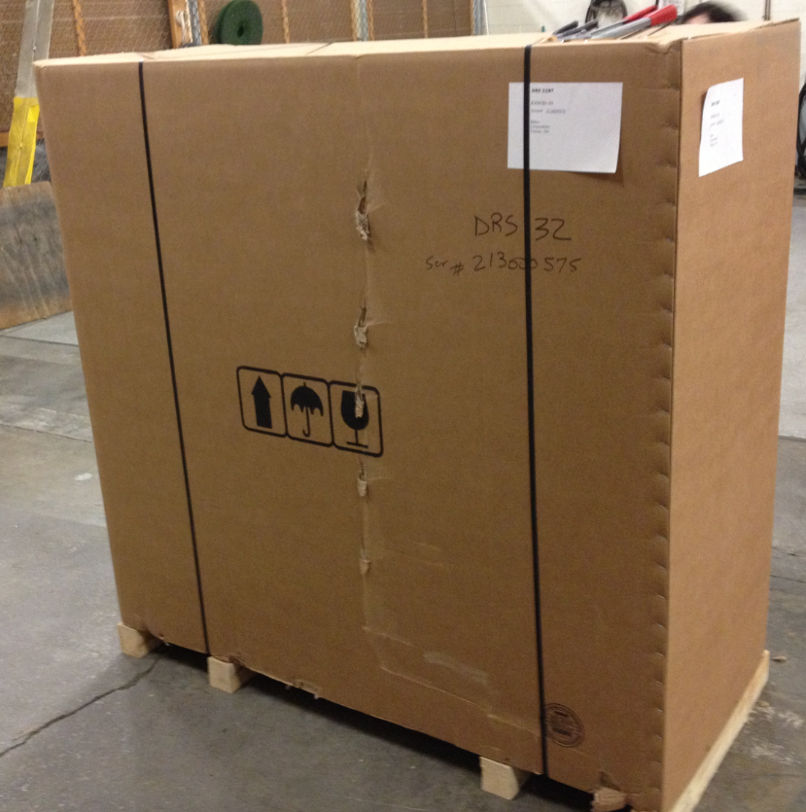

  - Place a machine ID tag onto the box. It should cover up the old ID number of the machine. Also, place a UN3171 Battery Powered Equipment decal (RLB016AV1) onto the front of the box.

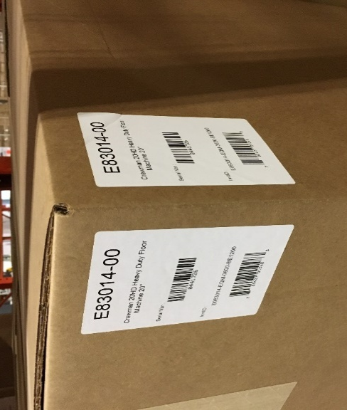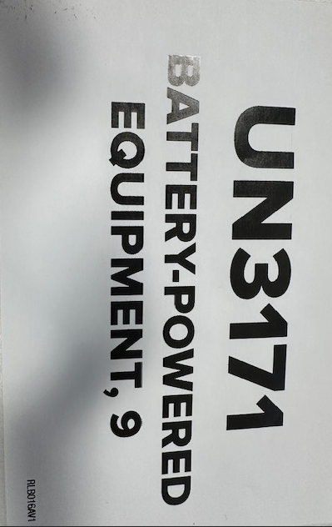

  - The machine is now ready for shipment.
- References (optional section as needed)

- Training Guide

Functional Training Groups Requiring Training
Equipment Group

- SOP Change Control

Date of Change | Reason for Change
Rev 01 | This is the first version of the S.O.P. hence there are no revisions to this document.
Rev 02 - 1/26/2018 | Added the Responsibilities Section
Rev 03 – 12/5/2025 | Removed QR codes and added Battery Powered Equipment sticker onto the box

Approvals

Submitter/Author Approval:__________________________________ Date:______________________

Management Approval:______________________________________ Date:______________________

QAU Approval:_____________________________________________ Date:______________________

